# **Send/Receive Email Using Gmail**

At this point you should have already created your password.

Visit emails.kmckenya.co.ke to find instructions on creating your password.

Want to have your email all in one place?

## Setting Up Email Through Your Gmail Account

### Required Information

* **Username:** (user)@kmckenya.co.ke (your full email address)
* **Password:** use whatever password you were assigned by the official support@kmckenya.co.ke
* **POP Server:** mail.kmckenya.co.ke
* **SMTP Server:** mail. kmckenya.co.ke

1. Log into your Gmail account
2. After your inbox loads, click on the “Gear” icon in the top right corner, and click the “See all settings” button.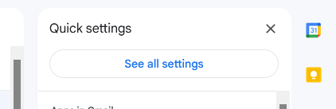
3. Under the “Accounts and Import” tab, find the “Check mail from other accounts” row. Click the **Add a mail account** link.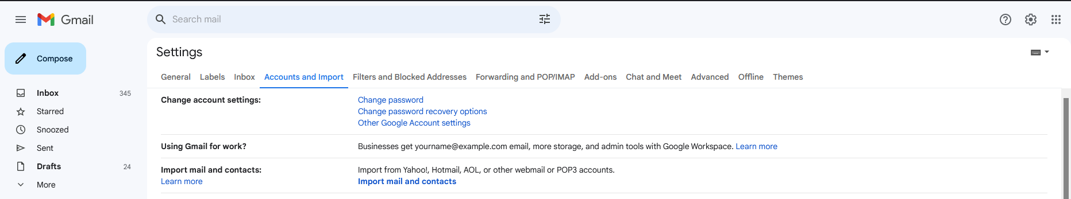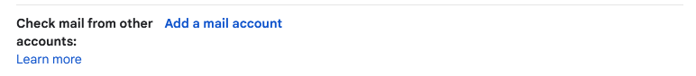
4. A new window will open, enter the email address that you would like to add to your account. (user@kmckenya.co.ke)Click **Next**.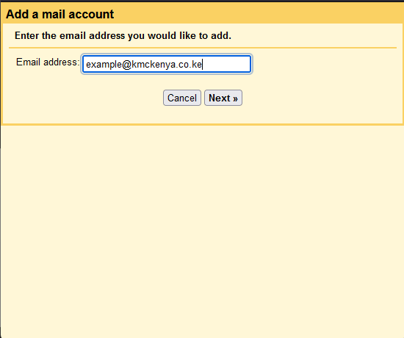
5. Select the option to “Import emails from my other account (POP3)” and click **Next**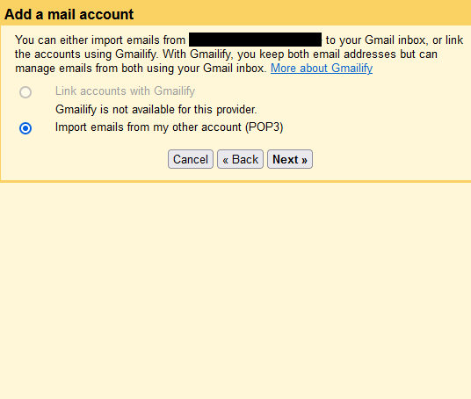
6. Enter the Username (your full email address ) and Password for the account you are adding.
7. For “POP Server”, enter mail.kmckenya.co.ke.
8. **Change the port number to 995** from the default 110.
9. There are 4 check boxes that should be unmarked by default, **check the box to “Always use a secure connection (SSL) when retrieving mail.”** and “Label incoming messages”. This is for maximum visibility when you receive an email. The remaining ones should remain unchecked. Click **Add Account.**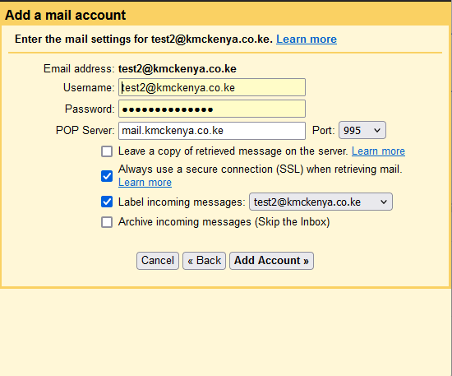
10. **Your account will be add. Check Yes. This is to confirm that you also want to send mail as “your professional email”. Then Next.**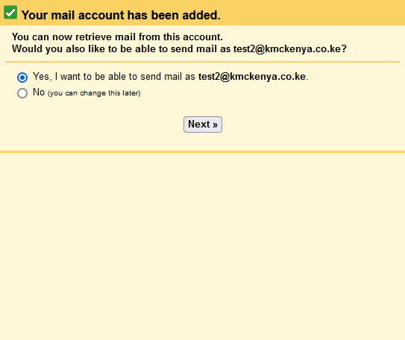
11. **Enter your Official Name in the Name field. This will show as the name when you send emails from your professional email.**
12. Be sure to have “Treat as an alias” checked and Click **Next Step.**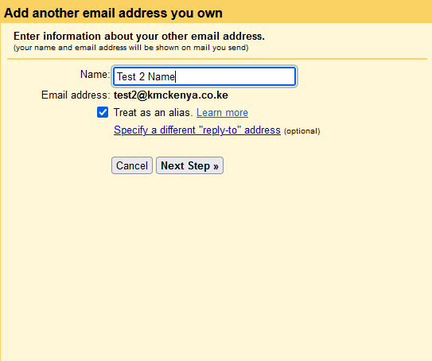
13. Input your credentials once more. And Change the port to 465 and check the “**Secured connection using SSL.** Click Add Account.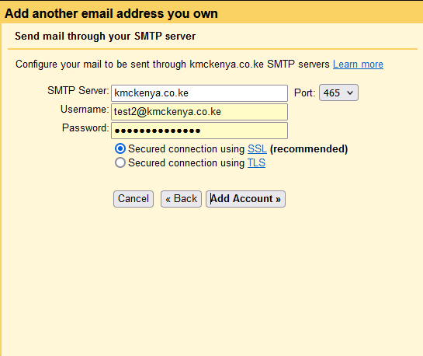
14. A verification link will be sent to your professional email via your normal email since you had already configured your normal email to receive emails on behalf of your professional email in the earlier stage of this process. The verification email should look like this: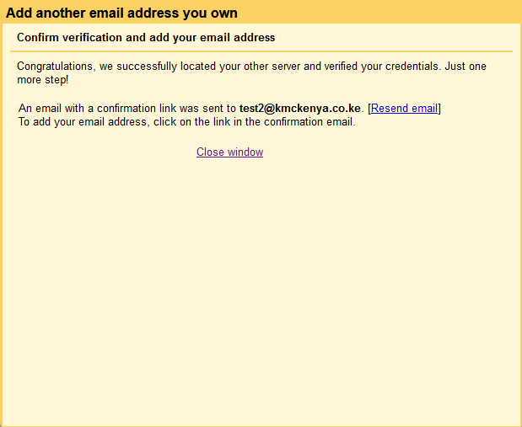 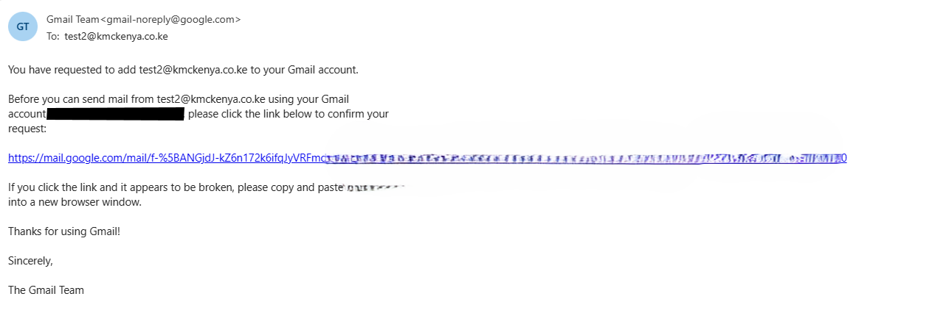
15. Click the link and **confirm** the addition. 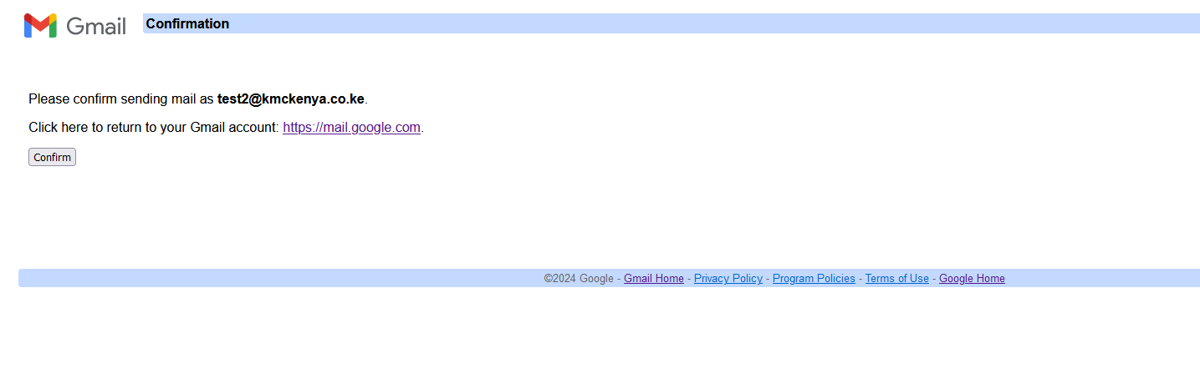
16. Make sure you see your email gets added.
17. Under the “Accounts and Import” tab, find the “Send mail as” row and confirm that the professional email was added and verified.
18. Make sure you check the “**Reply from the same address the message was sent to” radio button.**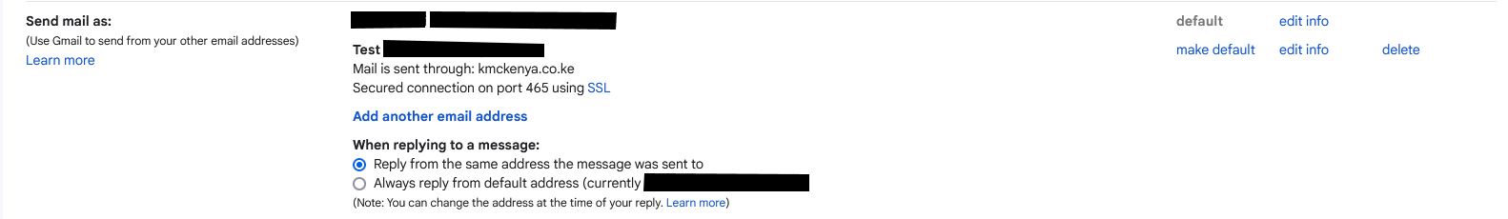
19. Still under the “Accounts and Import” tab, find the “Check mail from other accounts” row and confirm that the professional email was added. 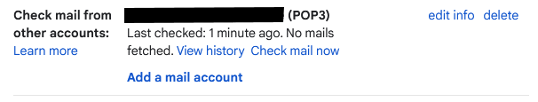
20. Make sure you change the label color to a vibrant color for maximum visibility. (Optional).

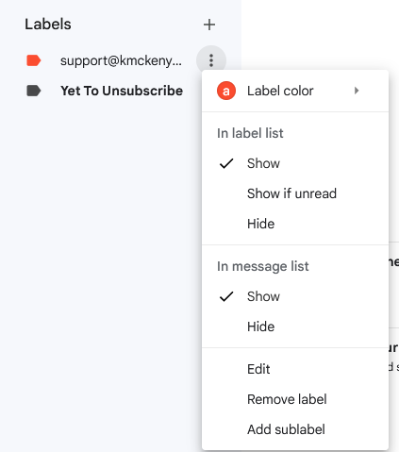

1. Congratulations. You have successfully added your **Professional email.**